[Thực hành] Spring MVC – Spring Security JSON Web Token

Mục tiêu:
Thực hành xác thực với Spring Security JSON Web Token

Mô tả:
Trong bài này chúng ta sẽ làm ví dụ về Spring Security cho những URL được dùng để gọi API (Restful Web Service)

Hướng dẫn:
Bước 1:
Tạo dự án Gradle có cấu trúc như sau:
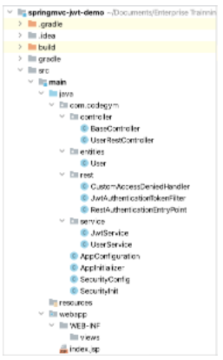
Cập nhật các dependency trong file build.gradle:
dependencies {
providedCompile group: 'javax.servlet', name: 'javax.servlet-api', version: '4.0.1'
implementation group: 'org.springframework', name: 'spring-core', version: '5.3.2'
implementation group: 'org.springframework', name: 'spring-context', version: '5.3.2'
implementation group: 'org.springframework', name: 'spring-beans', version: '5.3.2'
implementation group: 'org.springframework', name: 'spring-web', version: '5.3.2'
implementation group: 'org.springframework', name: 'spring-webmvc', version: '5.3.2'
implementation group: 'org.thymeleaf', name: 'thymeleaf-spring5', version: '3.0.11.RELEASE'
implementation group: 'nz.net.ultraq.thymeleaf', name: 'thymeleaf-layout-dialect', version: '2.5.2'
implementation group: 'org.springframework', name: 'spring-tx', version: '5.3.2'
implementation group: 'com.fasterxml.jackson.core', name: 'jackson-core', version: '2.12.1'
implementation group: 'com.fasterxml.jackson.core', name: 'jackson-databind', version: '2.12.1'
implementation group: 'org.springframework.security', name: 'spring-security-web', version: '5.4.2'
implementation group: 'org.springframework.security', name: 'spring-security-config', version: '5.4.2'
implementation group: 'org.springframework.security', name: 'spring-security-taglibs', version: '5.4.2'
implementation group: 'org.thymeleaf.extras', name: 'thymeleaf-extras-springsecurity5', version: '3.0.4.RELEASE'
implementation group: 'com.nimbusds', name: 'nimbus-jose-jwt', version: '4.20'
implementation group: 'org.apache.commons', name: 'commons-lang3', version: '3.7'
}
Chúng ta sử dụng thư viện nimbus-jose-jwt để tạo token (decode/encode token, chữ ký số).
Bước 2:
Tạo Class User:
package com.codegym.entities;
import java.util.ArrayList;
import java.util.List;
import org.springframework.security.core.GrantedAuthority;
import org.springframework.security.core.authority.SimpleGrantedAuthority;
import com.fasterxml.jackson.annotation.JsonIgnoreProperties;
import com.fasterxml.jackson.annotation.JsonInclude;
@JsonInclude(JsonInclude.Include.NON_NULL)
@JsonIgnoreProperties(value = { "roles", "authorities" })
public class User {
private int id;
private String username;
private String password;
private String[] roles;
public User() {
}
public User(int id, String username, String password) {
this.id = id;
this.username = username;
this.password = password;
}
// getter - setter
public int getId() {
return id;
}
public void setId(int id) {
this.id = id;
}
public String getUsername() {
return username;
}
public void setUsername(String username) {
this.username = username;
}
public String getPassword() {
return password;
}
public void setPassword(String password) {
this.password = password;
}
public String[] getRoles() {
return roles;
}
public void setRoles(String[] roles) {
this.roles = roles;
}
public List<GrantedAuthority> getAuthorities() {
List<GrantedAuthority> authorities = new ArrayList<GrantedAuthority>();
for (String role : roles) {
authorities.add(new SimpleGrantedAuthority(role));
}
return authorities;
}
}
Tạo BaseController:
package com.codegym.controller;
import org.springframework.stereotype.Controller;
import org.springframework.ui.Model;
import org.springframework.web.bind.annotation.RequestMapping;
import org.springframework.web.bind.annotation.RequestParam;
@Controller
public class BaseController {
@RequestMapping(value = { "/login", "/" })
public String login(@RequestParam(value = "error", required = false) final String error, final Model model) {
if (error != null) {
model.addAttribute("message", "Login Failed!");
}
return "login";
}
@RequestMapping("/admin")
public String admin() {
return "admin";
}
@RequestMapping("/logout")
public String logout(final Model model) {
model.addAttribute("message", "Logged out!");
return "login";
}
}
Tạo UserRestController:
package com.codegym.controller;
import java.util.List;
import javax.servlet.http.HttpServletRequest;
import org.springframework.beans.factory.annotation.Autowired;
import org.springframework.http.HttpStatus;
import org.springframework.http.ResponseEntity;
import org.springframework.security.authentication.AuthenticationManager;
import org.springframework.web.bind.annotation.PathVariable;
import org.springframework.web.bind.annotation.RequestBody;
import org.springframework.web.bind.annotation.RequestMapping;
import org.springframework.web.bind.annotation.RequestMethod;
import org.springframework.web.bind.annotation.RestController;
import com.codegym.entities.User;
import com.codegym.service.JwtService;
import com.codegym.service.UserService;
@RestController
@RequestMapping("/rest")
public class UserRestController {
@Autowired
private JwtService jwtService;
@Autowired
private UserService userService;
/* ---------------- GET ALL USER ------------------------ */
@RequestMapping(value = "/users", method = RequestMethod.GET)
public ResponseEntity<List<User>> getAllUser() {
return new ResponseEntity<List<User>>(userService.findAll(), HttpStatus.OK);
}
/* ---------------- GET USER BY ID ------------------------ */
@RequestMapping(value = "/users/{id}", method = RequestMethod.GET)
public ResponseEntity<Object> getUserById(@PathVariable int id) {
User user = userService.findById(id);
if (user != null) {
return new ResponseEntity<Object>(user, HttpStatus.OK);
}
return new ResponseEntity<Object>("Not Found User", HttpStatus.NO_CONTENT);
}
/* ---------------- CREATE NEW USER ------------------------ */
@RequestMapping(value = "/users", method = RequestMethod.POST)
public ResponseEntity<String> createUser(@RequestBody User user) {
if (userService.add(user)) {
return new ResponseEntity<String>("Created!", HttpStatus.CREATED);
} else {
return new ResponseEntity<String>("User Existed!", HttpStatus.BAD_REQUEST);
}
}
/* ---------------- DELETE USER ------------------------ */
@RequestMapping(value = "/users/{id}", method = RequestMethod.DELETE)
public ResponseEntity<String> deleteUserById(@PathVariable int id) {
userService.delete(id);
return new ResponseEntity<String>("Deleted!", HttpStatus.OK);
}
@RequestMapping(value = "/login", method = RequestMethod.POST)
public ResponseEntity<String> login(HttpServletRequest request, @RequestBody User user) {
String result = "";
HttpStatus httpStatus = null;
try {
if (userService.checkLogin(user)) {
result = jwtService.generateTokenLogin(user.getUsername());
httpStatus = HttpStatus.OK;
} else {
result = "Wrong userId and password";
httpStatus = HttpStatus.BAD_REQUEST;
}
} catch (Exception ex) {
result = "Server Error";
httpStatus = HttpStatus.INTERNAL_SERVER_ERROR;
}
return new ResponseEntity<String>(result, httpStatus);
}
}
Tạo UserService:
package com.codegym.service;
import java.util.ArrayList;
import java.util.List;
import org.apache.commons.lang3.StringUtils;
import org.springframework.stereotype.Service;
import com.codegym.entities.User;
@Service
public class UserService {
public static List<User> listUser = new ArrayList<User>();
static {
User userKai = new User(1, "kai", "123456");
userKai.setRoles(new String[] { "ROLE_ADMIN" });
User userSena = new User(2, "sena", "123456");
userSena.setRoles(new String[] { "ROLE_USER" });
listUser.add(userKai);
listUser.add(userSena);
}
public List<User> findAll() {
return listUser;
}
public User findById(int id) {
for (User user : listUser) {
if (user.getId() == id) {
return user;
}
}
return null;
}
public boolean add(User user) {
for (User userExist : listUser) {
if (user.getId() == userExist.getId() || StringUtils.equals(user.getUsername(), userExist.getUsername())) {
return false;
}
}
listUser.add(user);
return true;
}
public void delete(int id) {
listUser.removeIf(user -> user.getId() == id);
}
public User loadUserByUsername(String username) {
for (User user : listUser) {
if (user.getUsername().equals(username)) {
return user;
}
}
return null;
}
public boolean checkLogin(User user) {
for (User userExist : listUser) {
if (StringUtils.equals(user.getUsername(), userExist.getUsername())
&& StringUtils.equals(user.getPassword(), userExist.getPassword())) {
return true;
}
}
return false;
}
}
Chúng ta khởi tạo listUser và thực hiện truy vấn, login thêm/sửa/xóa user trên list này.
Ban đầu ta sẽ khởi tạo 2 tài khoản là kai/123456 với role ADMIN và sena/123456 với role là USER để đăng nhập và truy vấn.
Tạo JwtService:
package com.codegym.service;
import java.util.Date;
import org.springframework.stereotype.Service;
import com.nimbusds.jose.JWSAlgorithm;
import com.nimbusds.jose.JWSHeader;
import com.nimbusds.jose.JWSSigner;
import com.nimbusds.jose.JWSVerifier;
import com.nimbusds.jose.crypto.MACSigner;
import com.nimbusds.jose.crypto.MACVerifier;
import com.nimbusds.jwt.JWTClaimsSet;
import com.nimbusds.jwt.SignedJWT;
@Service
public class JwtService {
public static final String USERNAME = "username";
public static final String SECRET_KEY = "11111111111111111111111111111111";
public static final int EXPIRE_TIME = 86400000;
// OK
public String generateTokenLogin(String username) {
String token = null;
try {
// Create HMAC signer
JWSSigner signer = new MACSigner(generateShareSecret());
JWTClaimsSet.Builder builder = new JWTClaimsSet.Builder();
builder.claim(USERNAME, username);
builder.expirationTime(generateExpirationDate());
JWTClaimsSet claimsSet = builder.build();
SignedJWT signedJWT = new SignedJWT(new JWSHeader(JWSAlgorithm.HS256), claimsSet);
// Apply the HMAC protection
signedJWT.sign(signer);
// Serialize to compact form, produces something like
// eyJhbGciOiJIUzI1NiJ9.SGVsbG8sIHdvcmxkIQ.onO9Ihudz3WkiauDO2Uhyuz0Y18UASXlSc1eS0NkWyA
token = signedJWT.serialize();
} catch (Exception e) {
e.printStackTrace();
}
return token;
}
// OK
private JWTClaimsSet getClaimsFromToken(String token) {
JWTClaimsSet claims = null;
try {
SignedJWT signedJWT = SignedJWT.parse(token);
JWSVerifier verifier = new MACVerifier(generateShareSecret());
if (signedJWT.verify(verifier)) {
claims = signedJWT.getJWTClaimsSet();
}
} catch (Exception e) {
e.printStackTrace();
}
return claims;
}
// OK
private Date generateExpirationDate() {
return new Date(System.currentTimeMillis() + EXPIRE_TIME);
}
// OK
private Date getExpirationDateFromToken(String token) {
Date expiration = null;
JWTClaimsSet claims = getClaimsFromToken(token);
expiration = claims.getExpirationTime();
return expiration;
}
// OK
public String getUsernameFromToken(String token) {
String username = null;
try {
JWTClaimsSet claims = getClaimsFromToken(token);
username = claims.getStringClaim(USERNAME);
} catch (Exception e) {
e.printStackTrace();
}
return username;
}
// OK
private byte[] generateShareSecret() {
// Generate 256-bit (32-byte) shared secret
byte[] sharedSecret = new byte[32];
sharedSecret = SECRET_KEY.getBytes();
return sharedSecret;
}
// OK
private Boolean isTokenExpired(String token) {
Date expiration = getExpirationDateFromToken(token);
return expiration.before(new Date());
}
// OK
public Boolean validateTokenLogin(String token) {
if (token == null || token.trim().length() == 0) {
return false;
}
String username = getUsernameFromToken(token);
if (username == null || username.isEmpty()) {
return false;
}
if (isTokenExpired(token)) {
return false;
}
return true;
}
}
Class JwtService.java dùng để tạo và validate token.
Bước 3:
Tạo các file cấu hình spring mvc:
Tạo file AppConfiguration:
package com.codegym;
import org.springframework.beans.BeansException;
import org.springframework.context.ApplicationContext;
import org.springframework.context.ApplicationContextAware;
import org.springframework.context.annotation.Bean;
import org.springframework.web.servlet.config.annotation.WebMvcConfigurer;
import org.thymeleaf.extras.springsecurity5.dialect.SpringSecurityDialect;
import org.thymeleaf.spring5.SpringTemplateEngine;
import org.thymeleaf.spring5.templateresolver.SpringResourceTemplateResolver;
import org.thymeleaf.spring5.view.ThymeleafViewResolver;
import org.thymeleaf.templatemode.TemplateMode;
import org.springframework.context.annotation.ComponentScan;
import org.springframework.context.annotation.Configuration;
import org.springframework.context.annotation.PropertySource;
import org.springframework.transaction.annotation.EnableTransactionManagement;
import org.springframework.web.servlet.config.annotation.EnableWebMvc;
@Configuration
@EnableWebMvc
@EnableTransactionManagement
@ComponentScan("com.codegym")
public class AppConfiguration implements WebMvcConfigurer, ApplicationContextAware {
private ApplicationContext applicationContext;
@Override
public void setApplicationContext(ApplicationContext applicationContext) throws BeansException {
this.applicationContext = applicationContext;
}
//Cấu hình Thymleaf
@Bean
public SpringResourceTemplateResolver templateResolver() {
SpringResourceTemplateResolver templateResolver = new SpringResourceTemplateResolver();
templateResolver.setApplicationContext(applicationContext);
templateResolver.setPrefix("/WEB-INF/views");
templateResolver.setSuffix(".html");
templateResolver.setTemplateMode(TemplateMode.HTML);
templateResolver.setCharacterEncoding("UTF-8");
return templateResolver;
}
@Bean
public SpringTemplateEngine templateEngine() {
SpringTemplateEngine templateEngine = new SpringTemplateEngine();
templateEngine.setTemplateResolver(templateResolver());
templateEngine.addDialect(new SpringSecurityDialect());
return templateEngine;
}
@Bean
public ThymeleafViewResolver viewResolver() {
ThymeleafViewResolver viewResolver = new ThymeleafViewResolver();
viewResolver.setTemplateEngine(templateEngine());
viewResolver.setCharacterEncoding("UTF-8");
viewResolver.setForceContentType(true);
viewResolver.setContentType("text/html; charset=UTF-8");
return viewResolver;
}
}
Tạo file AppInitializer:
package com.codegym;
import org.springframework.web.servlet.support.AbstractAnnotationConfigDispatcherServletInitializer;
public class AppInitializer extends AbstractAnnotationConfigDispatcherServletInitializer {
@Override
protected Class<?>[] getRootConfigClasses() {
return new Class[]{SecurityConfig.class};
}
@Override
protected Class<?>[] getServletConfigClasses() {
return new Class[]{AppConfiguration.class};
}
@Override
protected String[] getServletMappings() {
return new String[]{"/"};
}
}
File cấu hình SecurityConfig:
package com.codegym;
import com.codegym.rest.CustomAccessDeniedHandler;
import com.codegym.rest.JwtAuthenticationTokenFilter;
import com.codegym.rest.RestAuthenticationEntryPoint;
import org.springframework.beans.factory.annotation.Autowired;
import org.springframework.context.annotation.ComponentScan;
import org.springframework.context.annotation.Configuration;
import org.springframework.http.HttpMethod;
import org.springframework.security.authentication.AuthenticationManager;
import org.springframework.security.config.BeanIds;
import org.springframework.security.config.annotation.authentication.builders.AuthenticationManagerBuilder;
import org.springframework.security.config.annotation.web.builders.HttpSecurity;
import org.springframework.security.config.annotation.web.configuration.EnableWebSecurity;
import org.springframework.security.config.annotation.web.configuration.WebSecurityConfigurerAdapter;
import org.springframework.security.config.http.SessionCreationPolicy;
import org.springframework.security.web.authentication.UsernamePasswordAuthenticationFilter;
import org.springframework.context.annotation.Bean;
@Configuration
@EnableWebSecurity
@ComponentScan("com.codegym")
public class SecurityConfig extends WebSecurityConfigurerAdapter {
@Bean
public JwtAuthenticationTokenFilter jwtAuthenticationTokenFilter() {
return new JwtAuthenticationTokenFilter();
}
@Bean
public RestAuthenticationEntryPoint restServicesEntryPoint() {
return new RestAuthenticationEntryPoint();
}
@Bean
public CustomAccessDeniedHandler customAccessDeniedHandler() {
return new CustomAccessDeniedHandler();
}
@Bean(BeanIds.AUTHENTICATION_MANAGER)
@Override
public AuthenticationManager authenticationManager() throws Exception {
return super.authenticationManager();
}
@Override
protected void configure(AuthenticationManagerBuilder auth) throws Exception {
auth.inMemoryAuthentication()
.withUser("kai").password("{noop}12345").roles("ADMIN")
.and()
.withUser("sena").password("{noop}12345").roles("USER");
}
@Override
protected void configure(HttpSecurity http) throws Exception {
http.csrf().ignoringAntMatchers("/**");
http.httpBasic().authenticationEntryPoint(restServicesEntryPoint());
http.authorizeRequests()
.antMatchers("/", "/rest/login").permitAll()
.antMatchers(HttpMethod.GET,"/rest/**").hasAnyRole("USER","ADMIN")
.antMatchers(HttpMethod.POST,"/rest/**").hasRole("ADMIN")
.antMatchers(HttpMethod.DELETE,"/rest/**").hasRole("ADMIN")
.antMatchers(HttpMethod.GET,"/admin/**").hasRole("ADMIN")
.anyRequest().authenticated()
.and().csrf().disable();
http.addFilterBefore(jwtAuthenticationTokenFilter(), UsernamePasswordAuthenticationFilter.class)
.exceptionHandling().accessDeniedHandler(customAccessDeniedHandler());
http.sessionManagement()
.sessionCreationPolicy(SessionCreationPolicy.STATELESS);
http.cors();
}
}
- Với các url /rest/** sẽ chỉ cho phép người dùng đã đăng nhập.
- Các url /rest/** với method GET (API lấy thông tin user) cho phép cả role ADMIN và USER truy cập, với các method “DELETE” và “POST” (xóa và tạo mới user) thì chỉ cho phép role ADMIN truy cập.
- Bean restServicesEntryPoint sẽ xử lý những request chưa được xác thực.
- Thay vì validate bằng form login, ta sử dụng bean jwtAuthenticationTokenFilter để thực hiện filter request.
- Trường hợp người dùng gửi request mà không có quyền sẽ do bean customAccessDeniedHandlerxử lý (Ví dụ chỉ có role USER nhưng gửi request xóa user)
File cấu hình SecurityInit:
package com.codegym;
import org.springframework.security.web.context.AbstractSecurityWebApplicationInitializer;
public class SecurityInit extends AbstractSecurityWebApplicationInitializer {
}
Class JwtAuthenticationTokenFilter:
package com.codegym.rest;
import java.io.IOException;
import javax.servlet.FilterChain;
import javax.servlet.ServletException;
import javax.servlet.ServletRequest;
import javax.servlet.ServletResponse;
import javax.servlet.http.HttpServletRequest;
import org.springframework.beans.factory.annotation.Autowired;
import org.springframework.beans.factory.annotation.Qualifier;
import org.springframework.security.authentication.AuthenticationManager;
import org.springframework.security.authentication.UsernamePasswordAuthenticationToken;
import org.springframework.security.core.context.SecurityContextHolder;
import org.springframework.security.core.userdetails.User;
import org.springframework.security.core.userdetails.UserDetails;
import org.springframework.security.web.authentication.UsernamePasswordAuthenticationFilter;
import org.springframework.security.web.authentication.WebAuthenticationDetailsSource;
import com.codegym.service.JwtService;
import com.codegym.service.UserService;
public class JwtAuthenticationTokenFilter extends UsernamePasswordAuthenticationFilter {
private final static String TOKEN_HEADER = "authorization";
@Autowired
private JwtService jwtService;
@Autowired
private UserService userService;
@Autowired
@Override
public void setAuthenticationManager(AuthenticationManager authenticationManager) {
super.setAuthenticationManager(authenticationManager);
}
@Override
public void doFilter(ServletRequest request, ServletResponse response, FilterChain chain)
throws IOException, ServletException {
HttpServletRequest httpRequest = (HttpServletRequest) request;
String authToken = httpRequest.getHeader(TOKEN_HEADER);
if (jwtService.validateTokenLogin(authToken)) {
String username = jwtService.getUsernameFromToken(authToken);
com.codegym.entities.User user = userService.loadUserByUsername(username);
if (user != null) {
boolean enabled = true;
boolean accountNonExpired = true;
boolean credentialsNonExpired = true;
boolean accountNonLocked = true;
UserDetails userDetail = new User(username, user.getPassword(), enabled, accountNonExpired,
credentialsNonExpired, accountNonLocked, user.getAuthorities());
UsernamePasswordAuthenticationToken authentication = new UsernamePasswordAuthenticationToken(userDetail,
null, userDetail.getAuthorities());
authentication.setDetails(new WebAuthenticationDetailsSource().buildDetails(httpRequest));
SecurityContextHolder.getContext().setAuthentication(authentication);
}
}
chain.doFilter(request, response);
}
}
Class RestAuthenticationEntryPoint:
package com.codegym.rest;
import java.io.IOException;
import javax.servlet.http.HttpServletRequest;
import javax.servlet.http.HttpServletResponse;
import org.springframework.security.core.AuthenticationException;
import org.springframework.security.web.AuthenticationEntryPoint;
public class RestAuthenticationEntryPoint implements AuthenticationEntryPoint {
public void commence(HttpServletRequest request, HttpServletResponse response,
AuthenticationException authException) throws IOException {
// response.sendError(HttpServletResponse.SC_UNAUTHORIZED, "Unauthorized");
response.setStatus(HttpServletResponse.SC_UNAUTHORIZED);
response.getWriter().write("Unauthorized");
}
}
Class CustomAccessDeniedHandler:
package com.codegym.rest;
import java.io.IOException;
import javax.servlet.ServletException;
import javax.servlet.http.HttpServletRequest;
import javax.servlet.http.HttpServletResponse;
import org.springframework.security.access.AccessDeniedException;
import org.springframework.security.web.access.AccessDeniedHandler;
public class CustomAccessDeniedHandler implements AccessDeniedHandler {
@Override
public void handle(HttpServletRequest request, HttpServletResponse response, AccessDeniedException exc)
throws IOException, ServletException {
// Authentication auth = SecurityContextHolder.getContext().getAuthentication();
response.setStatus(HttpServletResponse.SC_FORBIDDEN);
response.getWriter().write("Access Denied!");
}
}
Bước 4:
Demo:
Cấu hình và chạy dự án.
Với các URL Restful Web Service ta sẽ sử dụng postman extension trên chrome để gửi các request thêm, xóa, lấy thông tin đối tượng user.
Trường hợp gửi request lấy thông tin tất cả user mà không có token đính kèm (chưa đăng nhập)
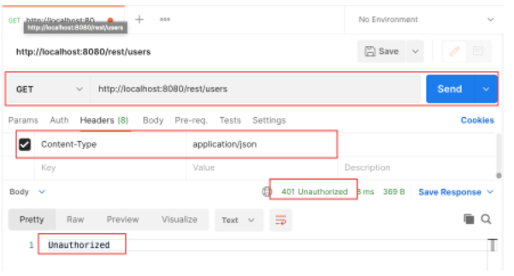
Đăng nhập với tài khoản sena/123456
Kết quả trả về 1 token
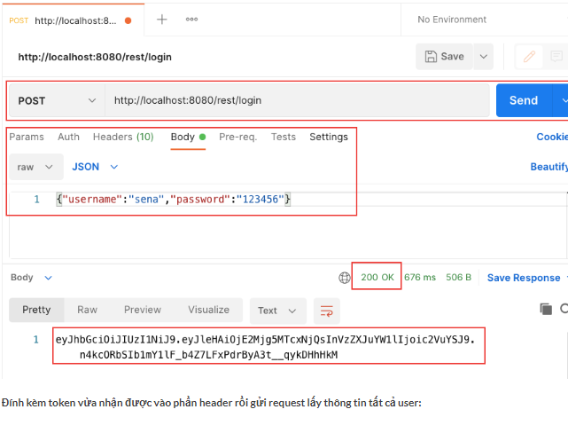
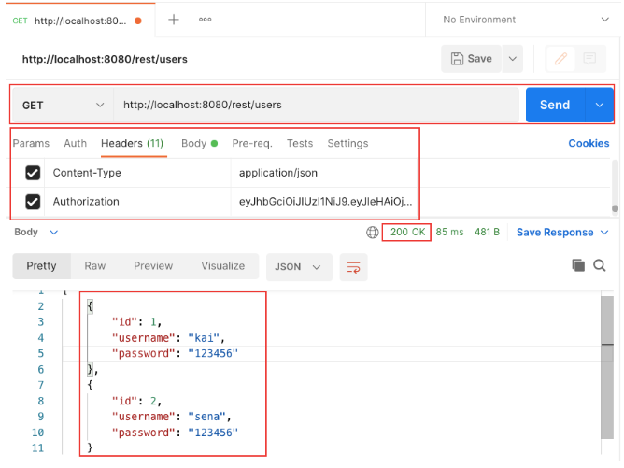
Gửi request tạo mới đối tượng user:
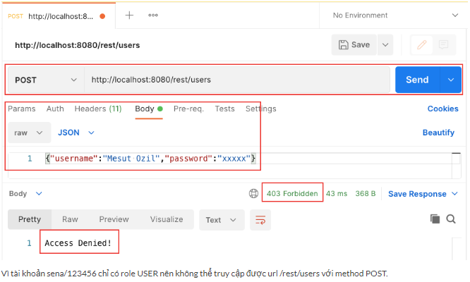
Đăng nhập lại với tài khoản kai/123456 và thực hiện thêm mới user:
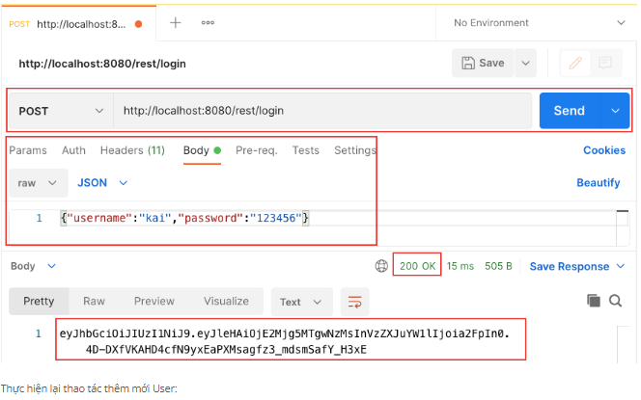
Xác định Headers và Body:
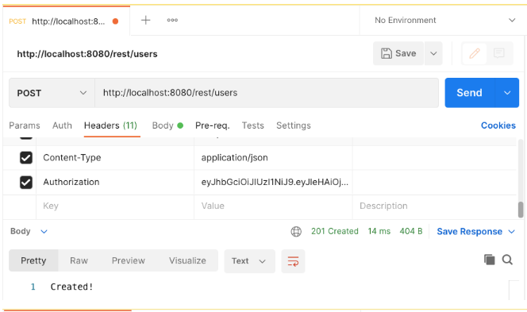
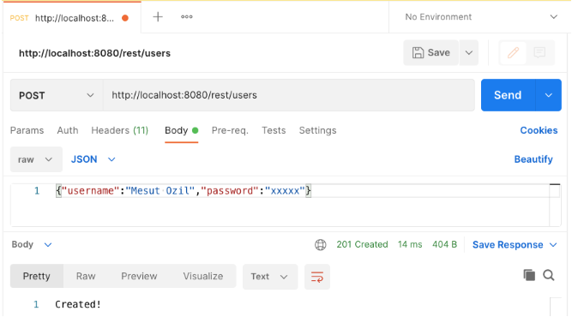
Load lại danh sách User sau khi thêm mới thành công:
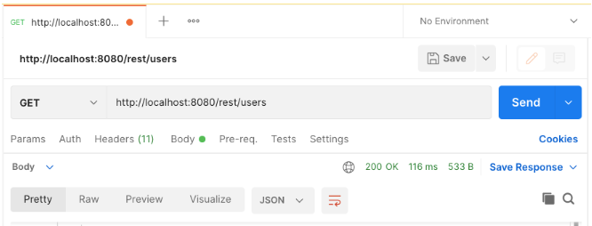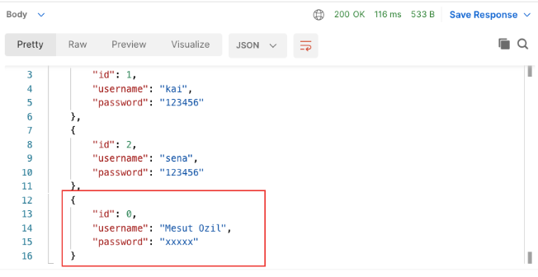
Mã nguồn tham khảo: https://github.com/codegym-vn/springmvc-jwt-restful-example
Hướng dẫn nộp bài:
- Up mã nguồn lên git
- Paste link vào phần nộp bài

